**SKU CODE: OLPLED**

Lunaqua Power LED Spot (Warm White)

Perfect illumination for any lighting situation

Flexible, extensible system that is suited for installation underwater and above water:

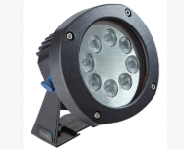

|  |
| --- |
| With 8pcs of super-bright LED  Beam angle: 15 Degrees |
| Size: 145x160X182 |
| Power: 24 V DC |
| Housing material: Stainless Steel |
| Cable length: Optional |
| Colour: Warm White |

**SKU: OLPLEDC**

**Lunaqua Power LED Cable 10m**

**SKU CODE: OLPLEDD**

**Lunaqua Power LED Driver 30W**

The Oase LunAqua Power LED Driver 30w is suitable for use with the Oase LunAqua Power LED and LunAqua Power LED XL range of pond and garden lighting. This high-quality driver is IP68 rated, easy and safe to operate both above and below water, up to a depth of 4m and comes backed by a 2+1=3-year guarantee for peace of mind.

